**Supplementary Figures**



**Supplementary Figure 1 | Transporter Truncation Distribution | a)** Proportional transporter counts of each transporter within each phylogroup and superfamily showing truncation classification. Truncation categories are given in the key.

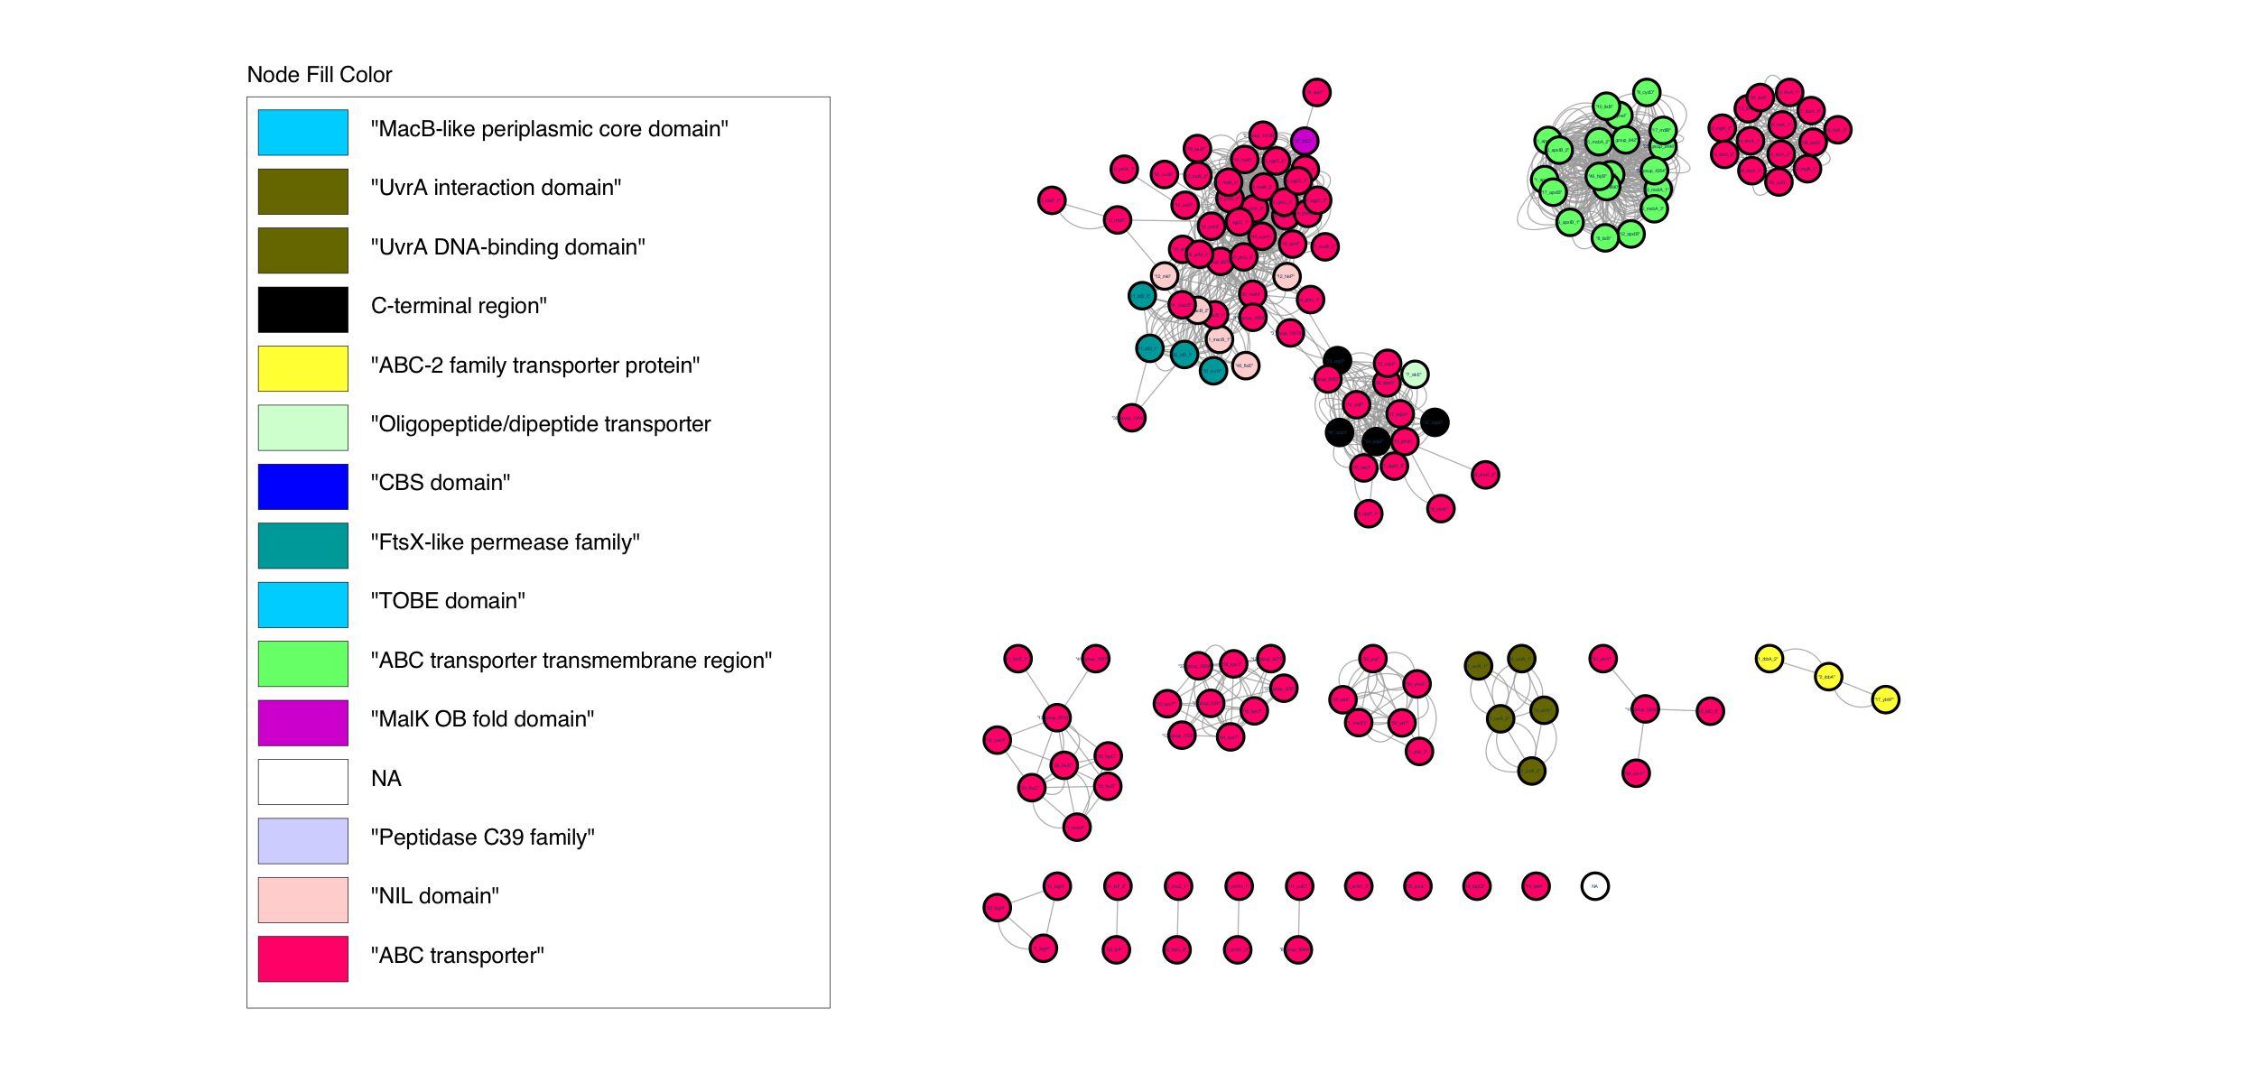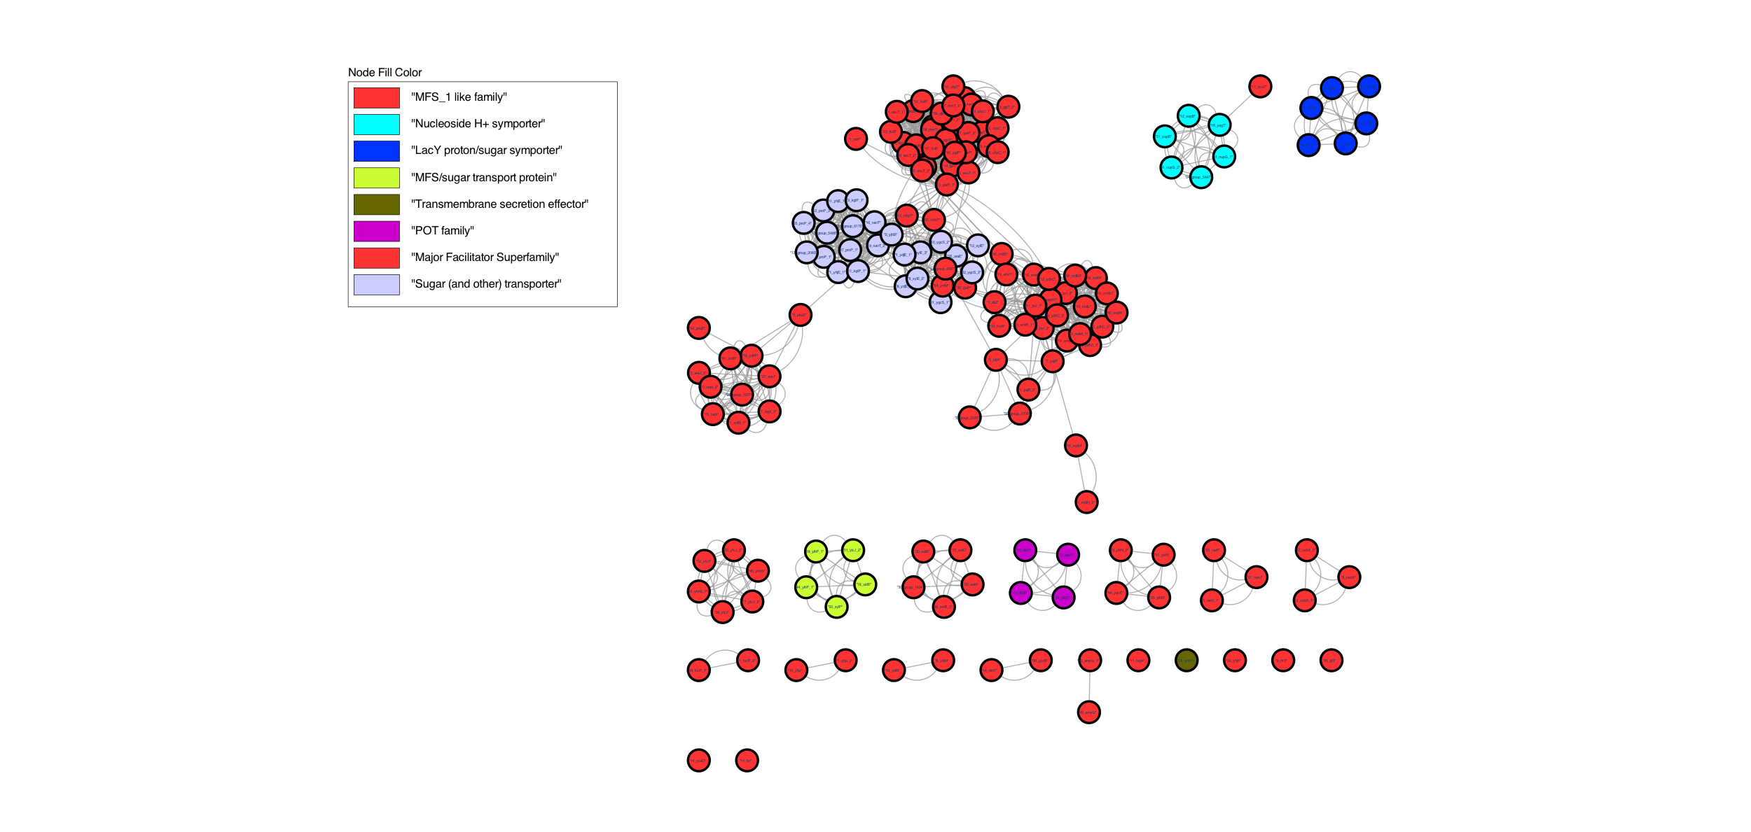

**Supplementary Figure 2 |ABC and MFS Transporter Networks Clustered with Domain Annotations**



**Supplementary Figure 3 | ABC Cluster A and Cluster B Transporter Phylogeny | a)** Phylogenetic tree of cluster A and B combination. Phylogenetic reconstruction made with maximum likelihood using iqtree (ver 1.6.12). Domain annotations indicated in the key. Bootstrap values indicated in blue dots.



**Supplementary Figure 4 | Transporter Phylogroup Distribution | a)** Proportional and overall abundance stacked bar charts to show gene classifications within each phylogroup and superfamily. Proportional counts are inferred as the total number of genes in a classification (core, intermediate, rare, varied) / the total number of genes within a phylogroup transporter superfamily. Total counts are normalized against the total number of genomes within each phylogroup.